**DAILY ONLINE ACTIVITIES SUMMARY**

|  |  |  |  |  |  |  |  |  |
| --- | --- | --- | --- | --- | --- | --- | --- | --- |
| **Date:** | **02/06/2020** | | | | | **Name:** | **Anjali Manohar Prabhu** | |
| **Sem & Sec** | **4th Sem Section - ‘A’** | | | | | **USN:** | **4AL18CS007** | |
| **Online Test Summary** | | | | | | | | |
| **Subject** | | **NO TEST** | | | | | | |
| **Max. Marks** | | **-** | | **Score** | | | **-** | |
| **Certification Course Summary** | | | | | | | | |
| **Course** | **Introduction to Ethical hacking** | | | | | | | |
| **Certificate Provider** | | | 1. **Great Learning Academy** | | **Duration** | | | **2.5hrs** |
| **Coding Challenges** | | | | | | | | |
| **Problem Statement: 1. Given an array of positive integers. Write a C program to find inversion count of array**   1. **Write a Java program to find the perfect sum problem.** 2. **Write a Java program, an array of integer data to be initialized.** | | | | | | | | |
| **Status: Completed** | | | | | | | | |
| **Uploaded the report in Github** | | | | | **YES** | | | |
| **If yes Repository name** | | | | | [**https://github.com/vinisharen/lockdown-coding**](https://github.com/vinisharen/lockdown-coding) | | | |
| **Uploaded the report in slack** | | | | | **YES** | | | |

Online Test Details: NO TEST WAS CONDUCTED

Certification Course Details:

**Ethical Hacking**, also known as *penetration testing*, *intrusion testing*, or *red teaming*, is the controversial act of locating weaknesses and vulnerabilities of computer and information systems by duplicating the intent and actions of malicious [hackers](http://en.wikipedia.org/wiki/Hacker_(computer_security)).

An **Ethical Hacker**, also known as a *whitehat hacker*, or simply a [*whitehat*](http://en.wikipedia.org/wiki/Whitehat), is a security professional who applies their hacking skills for defensive purposes on behalf of the owners of information systems. Nowadays, certiﬁed ethical hackers are among the most sought after information security employees in large organizations such as [Wipro](http://www.wipro.com/), [Infosys](http://www.infosys.com/), [IBM](http://www.ibm.com/ca/en/), [Airtel](http://www.airtel.in/) and [Reliance](http://www.rcom.co.in/webapp/Communications/rcom/index.jsp) among others.

**SNAPSHOT:**

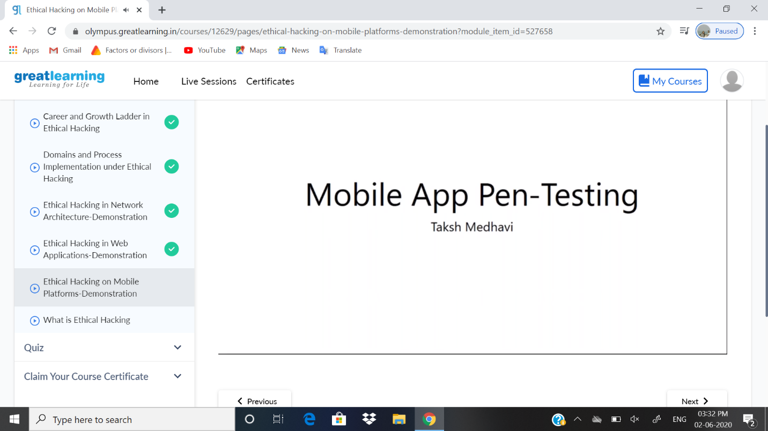

ONLINE CODING DETAILS:

PROBLEM 1: **Given an array of positive integers. Write a C program to find inversion count of array**

SNAPSHOT:

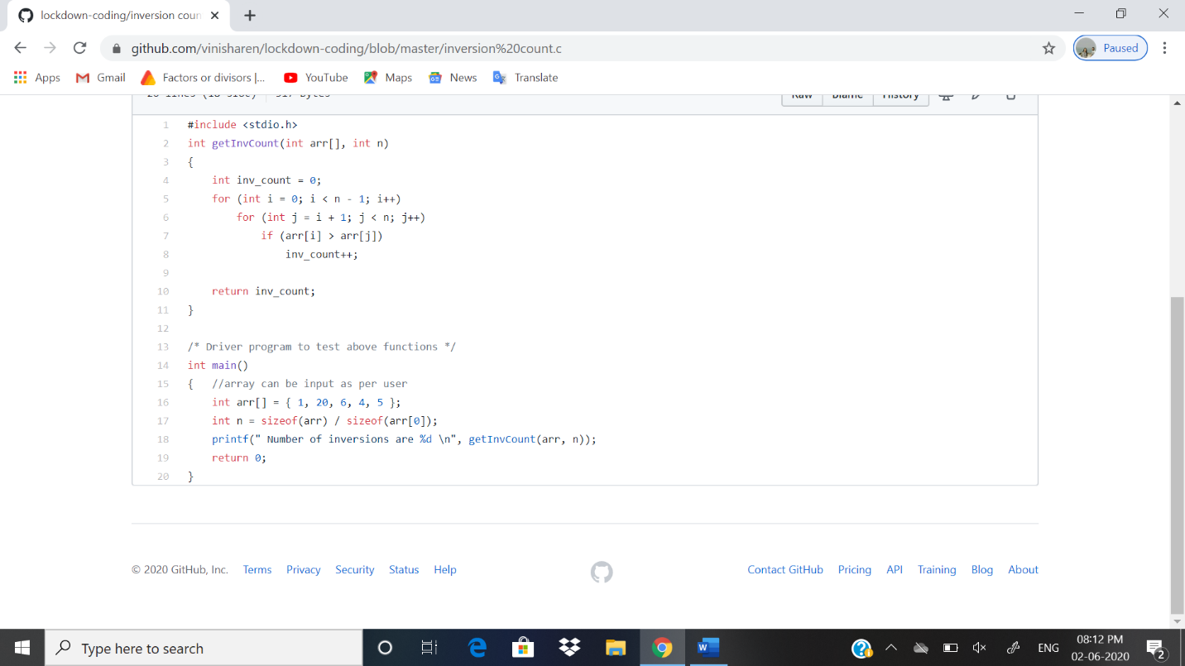

PROBLEM 2: **Write a Java program to find the perfect sum problem.**

**SNAPSHOT:**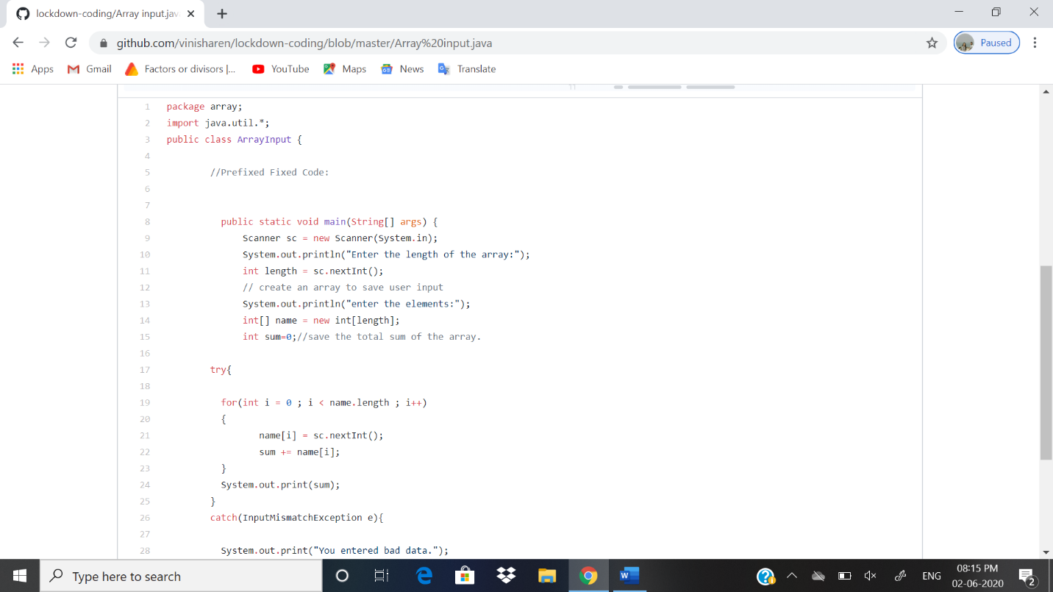

PROBLEM 3: **Write a Java program, an array of integer data to be initialized.**

SNAPSHOT: 